LEVEL 6 — RESEARCH TRACK CAPSTONE
Advanced Machine Learning
(Applied Judiciously)
Knowing precisely where sophisticated methods earn their complexity — and where they do not
Covers: Representation learning / deep learning / Transformers · reinforcement learning · online learning / meta-learning · Bayesian optimisation · ensemble methods

Table of Contents
Right-click and choose “Update Field” (or “Update entire table”) after opening in Word to populate page numbers.
Table of Contents 2
8. Advanced Machine Learning (Applied Judiciously) (Level 6) 3
8.1 Learning Position at a Glance 3
8.2 Understand Before Proceeding: The Complexity Tax 3
8.3 Representation Learning, Deep Learning & Transformers 4
8.4 Reinforcement Learning 4
8.5 Online Learning & Meta-Learning 5
8.6 Bayesian Optimisation 6
8.7 Ensemble Methods 7
8.8 Worked Exercise — Model Answer 8
8.9 Common Mistakes — Deeper Look 8
8.10 Advanced Extensions 9
8.11 Professional Applications 9

8. Advanced Machine Learning (Applied Judiciously) (Level 6)
Covers: Representation learning/deep learning/Transformers · reinforcement learning · online learning/meta-learning · Bayesian optimisation · ensemble methods

8.1 Learning Position at a Glance
- What it is: The most sophisticated end of the machine-learning toolkit, including methods that learn from sequential interaction with an environment (reinforcement learning).
- Why it matters: These methods are powerful but also the most prone to being used because they are fashionable rather than because they are the right tool; expert practice means knowing precisely where each one earns its complexity.
- Prerequisites: Machine Learning for Quant Research (Level 3, Depth 3+); Advanced Statistical Research.
- Understand before proceeding: Do not reach for deep learning, reinforcement learning or Transformers merely because they are sophisticated. Establish first, with a simpler model, that there is genuine unexplained structure worth the added complexity, data requirements and interpretability cost.
- Connects to Research: Legitimate uses include sequence modelling for order-book data (where a Transformer’s inductive bias plausibly fits) and execution problems naturally framed as sequential decision-making (reinforcement learning).
- Connects to Development: These methods have real production costs: training infrastructure, monitoring for drift, and interpretability tooling (e.g. SHAP) all scale up in complexity.
- Connects to Trading: Reinforcement learning has genuine, well-documented applications in optimal execution (learning an order-slicing policy) more than in raw alpha generation.
- Practical exercise: Compare a simple gradient-boosted model against a small Transformer on the same order-book prediction task, matched for the same validation methodology, and report whether the added complexity is justified by the results.
- Common beginner mistakes:
- Using reinforcement learning for a problem that is really supervised learning in disguise, adding unnecessary complexity and instability.
- Judging a model ‘better’ purely on in-sample performance uplift without accounting for its far greater overfitting capacity.
- Advanced extensions: This is the frontier of the curriculum — further depth here should be driven by a specific, well-defined research or execution problem, not general curiosity.
- Professional applications: Optimal execution policies; order-book sequence modelling; select advanced signal research.

8.2 Understand Before Proceeding: The Complexity Tax
Every method in this section trades a specific cost for a specific capability. Deep learning and Transformers can represent far more intricate functions than a linear model or a gradient-boosted tree, but that same representational power means they can fit noise just as fluently as they fit signal — and with far less data per parameter than intuition suggests is safe. Reinforcement learning can, in principle, learn an optimal sequential policy directly from interaction, but it is also notoriously data-hungry, unstable to train, and difficult to validate offline in a way that guarantees good behaviour once deployed. None of this makes these methods wrong; it makes them expensive, in data, in engineering effort, and in the ability to explain a model’s behaviour to a risk committee. The question this section keeps returning to is not ‘can a more sophisticated method be applied here?’ — it almost always can — but ‘has a simpler method been shown to be inadequate first, and does the specific structure of this problem plausibly justify the added cost?’
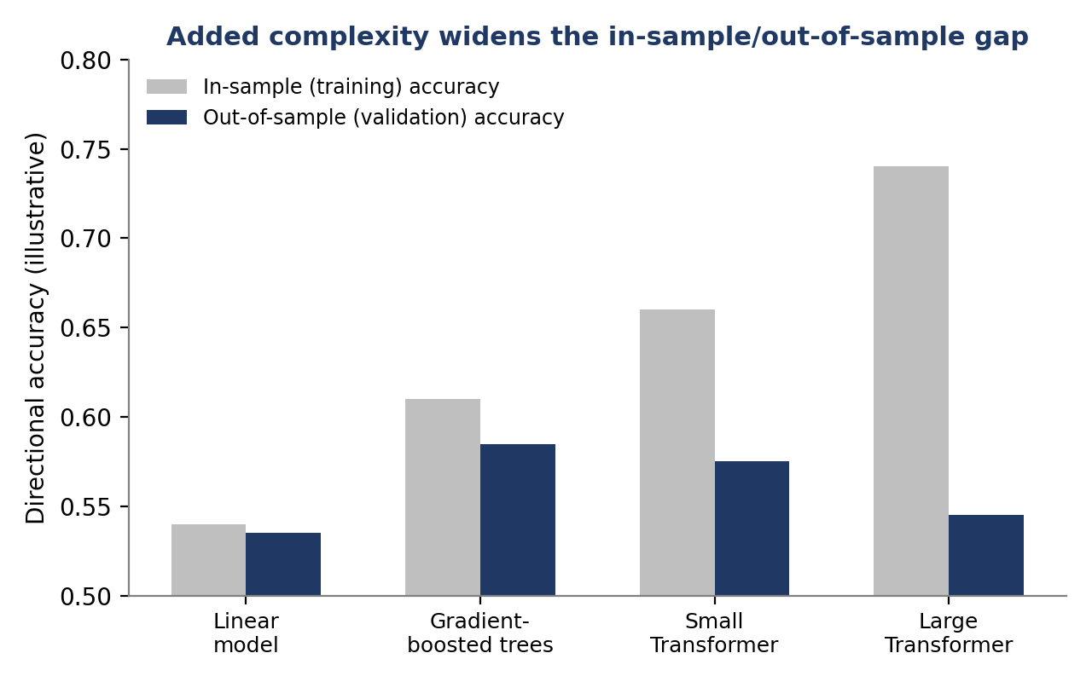
Figure 8.1 — Illustrative in-sample vs. out-of-sample accuracy across four model classes: raw training performance rises steadily with model complexity, but validation performance peaks with gradient-boosted trees and then falls as larger, more flexible models increasingly fit noise specific to the training sample.
⚠ A standing discipline for this entire section
- Before adopting any method from §8.3–§8.7, fit the simplest reasonable baseline first and record its out-of-sample performance.
- Only adopt the more sophisticated method if it produces a validation-set improvement that would not plausibly be explained by chance, given the same multiple-testing caution from §6.6.

8.3 Representation Learning, Deep Learning & Transformers
Representation learning refers to methods that learn a useful numerical encoding of raw, unstructured input — order-book snapshots, news text, satellite imagery — rather than relying on hand-engineered features. Deep neural networks are the dominant tool for this, building the encoding as a stack of learned transformations. Transformers are a specific deep-learning architecture built around an attention mechanism, which lets the model learn, for each element of a sequence, how much to weight every other element when forming its representation — an inductive bias that fits problems with rich, variable-range sequential dependence particularly well.
- Where the inductive bias plausibly fits: Order-book sequence modelling is a genuine candidate: the state of an order book is naturally a sequence of events (orders, cancellations, trades) with dependence structure across many recent events, which is exactly the setting attention mechanisms were designed for.
- Where it is often misapplied: Tabular, cross-sectional factor data (one row per stock per day, a fixed set of engineered features) rarely has the sequential or spatial structure that justifies a deep architecture’s inductive bias, and simpler tree-based methods are frequently competitive or superior on exactly this kind of data.
- The data-volume requirement: Deep architectures typically need orders of magnitude more training examples than tree-based or linear models to reach their potential; the high-frequency, large-sample settings where this data volume is available (tick and order-book data) are precisely where these methods are most defensible.

8.4 Reinforcement Learning
Reinforcement learning (RL) frames a problem as an agent taking sequential actions in an environment to maximise cumulative reward, learning a policy — a mapping from observed state to action — through trial and interaction rather than from labelled examples. This framing is a natural fit for optimal execution: an agent observes the current order book and time remaining, chooses how much to trade now, and receives a reward tied to execution cost, repeating this decision many times across an order’s lifetime.
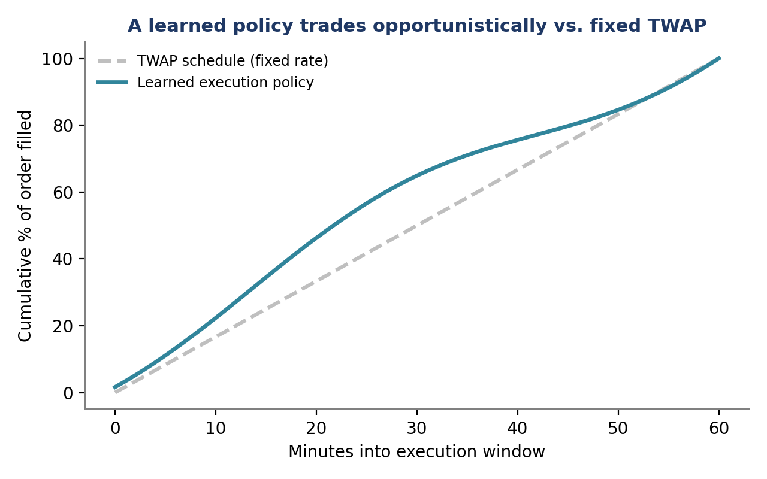
Figure 8.2 — A learned execution policy can trade opportunistically — accelerating when conditions are favourable and slowing when they are not — compared with a fixed time-weighted-average-price (TWAP) schedule that ignores the current state of the market entirely.
Where RL genuinely earns its complexity
- Optimal execution: the problem is inherently sequential (many small decisions over an order’s lifetime), the state (order book, time remaining, inventory) is well-defined, and a reward signal (implementation shortfall) is directly measurable — all the ingredients RL needs to work well.
Where RL is usually the wrong tool
- Raw alpha generation — predicting whether an asset will go up or down — is fundamentally a supervised learning problem (there is a labelled outcome to predict) dressed up as a sequential decision problem; applying RL here typically adds training instability and sample-inefficiency without a corresponding benefit, since there is no genuine multi-step decision structure to exploit (see the common mistake in §8.9).

8.5 Online Learning & Meta-Learning
Online learning updates a model incrementally as new data arrive, one observation (or small batch) at a time, rather than retraining from scratch on an ever-growing static dataset. This matters directly for the alpha-decay and regime-shift problems introduced in earlier sections (§6.3, §7.3): a model that can update quickly is better positioned to track a market whose statistical properties are themselves changing over time.
Meta-learning (‘learning to learn’) goes a step further: rather than learning a single fixed model, it learns a starting point or an adaptation procedure that allows a model to adapt very quickly to a new task or regime using only a small amount of new data, by training across many related tasks or historical regimes in advance and extracting what tends to transfer across them.
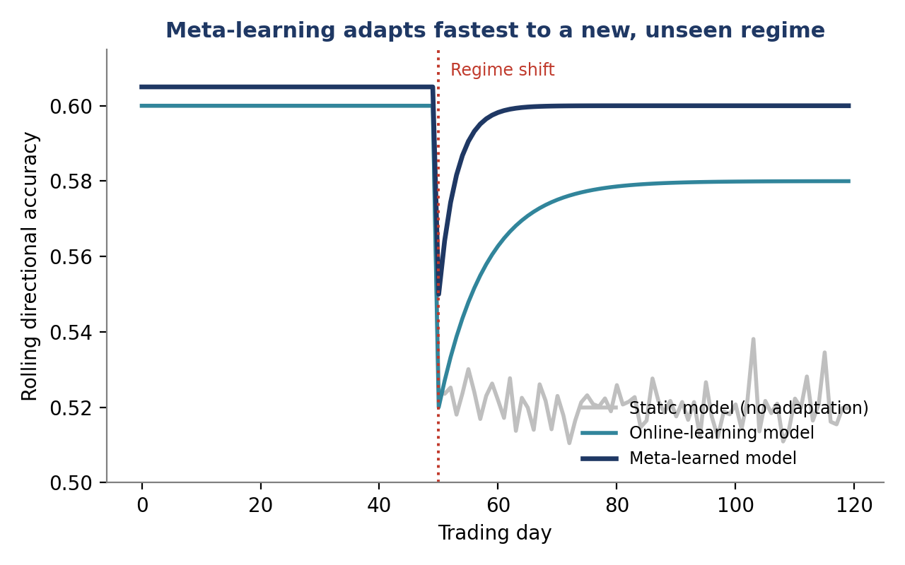
Figure 8.4 — After an unseen regime shift, a static model’s performance collapses and stays degraded, an online-learning model gradually recovers as it accumulates new post-shift data, and a meta-learned model — pre-trained to adapt quickly across many historical regimes — recovers fastest.
- Online learning fits well when: Distribution shift is gradual and continuous, and a moderate lag in adaptation is tolerable.
- Meta-learning fits well when: The firm has experienced many distinct historical regimes to learn an adaptation procedure from, and fast adaptation to a genuinely new regime (with very little post-shift data) has high value — for example, around sudden, discrete market structure changes.

8.6 Bayesian Optimisation
Many machine-learning methods (and even some classical strategies) have hyperparameters — a learning rate, a regularisation strength, a lookback window — that must be tuned, and evaluating any single configuration can be expensive (retraining a large model, or rerunning a slow backtest). Bayesian optimisation treats the search for good hyperparameters itself as a modelling problem: it builds a probabilistic model of how validation performance varies across the hyperparameter space, and uses that model to choose the next configuration to try — balancing exploring uncertain regions against exploiting regions already known to perform well — rather than exhaustively trying every combination (grid search) or trying configurations at random.
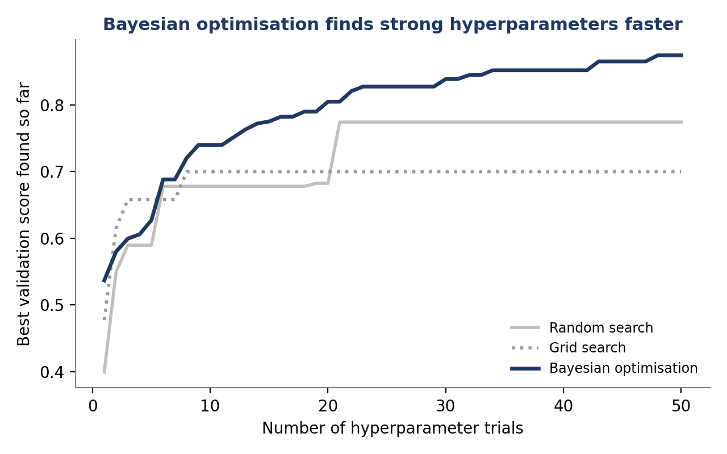
Figure 8.3 — Illustrative comparison: Bayesian optimisation typically finds strong hyperparameter configurations using far fewer expensive trials than exhaustive grid search or unguided random search, because each new trial is chosen using what has been learned from all previous trials.
⚠ A direct link back to §6.6
- Every hyperparameter configuration tried during a Bayesian optimisation search is itself a ‘look’ at the validation data, and a large search still carries real multiple-testing risk even though it is more sample-efficient than grid or random search.
- The number of configurations tried should be logged and accounted for, exactly as in §6.6’s researcher-degrees-of-freedom discussion, rather than assumed harmless simply because the search itself was principled.

8.7 Ensemble Methods
An ensemble combines predictions from multiple models to produce a final prediction that is typically more robust than any single constituent model. Ensembles work because different models tend to make different, partially independent errors; when those errors are not perfectly correlated, combining the models' outputs cancels out some of each individual model's idiosyncratic mistakes.
- Bagging: Trains many versions of the same model on different bootstrapped resamples of the data and averages their predictions, primarily reducing variance (overfitting to sample-specific noise) — random forests are a well-known example.
- Boosting: Trains models sequentially, with each new model focused specifically on correcting the errors of the ensemble so far; gradient-boosted trees, one of the strongest and most widely used tabular-data methods in quant research, are a boosting method.
- Stacking / model blending: Combines predictions from structurally different model types (e.g. a linear model, a tree-based model and a neural network) using a further model that learns how to weight each constituent, which can capture complementary strengths across genuinely different modelling approaches rather than many versions of the same one.
Ensembles are, in a specific sense, the least fashionable and most consistently useful method in this entire section: they rarely require exotic infrastructure, they degrade gracefully rather than catastrophically when one constituent model is weak, and gradient-boosted ensembles in particular remain a strong, well-understood default for the tabular, cross-sectional data that dominates much of quant research — exactly the baseline the practical exercise in §8.8 asks to be taken seriously.

8.8 Worked Exercise — Model Answer
Exercise: Compare a simple gradient-boosted model against a small Transformer on the same order-book prediction task, matched for the same validation methodology, and report whether the added complexity is justified by the results.
Model answer structure
- Match the comparison fairly. Both models must see identical training, validation and test splits (respecting time order, per §6.7’s walk-forward discipline), identical target definitions, and a comparable, reasonable amount of hyperparameter tuning effort for each — an under-tuned Transformer compared against a well-tuned gradient-boosted model (or vice versa) answers a different, less useful question.
- Report both in-sample and out-of-sample performance for each model, explicitly, as in Figure 8.1 — the in-sample number alone cannot answer the question the exercise asks.
- State the decision rule in advance: for instance, ‘the Transformer will be judged to have earned its complexity only if its out-of-sample performance exceeds the gradient-boosted model’s by more than [a pre-specified margin], since a smaller improvement is within the range plausibly explained by noise given the validation set size.’
- A common, defensible finding on this exact task: with a modest amount of order-book data, the gradient-boosted model matches or beats the small Transformer out-of-sample despite the Transformer’s higher in-sample fit — in which case the honest conclusion is that the added complexity was not justified at the available data scale, and the gradient-boosted model should be preferred until substantially more data or a clearer structural reason changes that answer.
- If the Transformer does justify its complexity, document specifically why — for example, a genuine sequential dependence in the order-book data that the gradient-boosted model’s feature set could not capture — so the result is explainable rather than a bare performance number.

8.9 Common Mistakes — Deeper Look
Mistake: Using reinforcement learning for a problem that is really supervised learning in disguise
A useful diagnostic question is whether the problem has a genuine multi-step decision structure in which an action taken now changes the state the agent will face later, with a delayed reward that depends on the whole sequence of actions — optimal execution has this property (how much is traded now affects the price and inventory faced on the next decision). Predicting next-period returns from today’s features does not have this property: there is a direct, immediately observable label (the next return) for each input, with no action of the model's own that changes the environment it will next observe. Framing this second kind of problem as reinforcement learning — with an agent, a policy, and a reward — imports RL’s well-known training instability and sample-inefficiency (§8.4) for no corresponding benefit, since a standard supervised model, trained directly on the available labels, solves the same problem more directly, more stably, and with far less data.
Mistake: Judging a model ‘better’ purely on in-sample performance uplift without accounting for its far greater overfitting capacity
Figure 8.1 makes this concrete: a large Transformer’s in-sample accuracy can comfortably exceed a linear model’s or a gradient-boosted model’s, while its out-of-sample accuracy is worse than both, because its far larger number of parameters gives it more capacity to fit sample-specific noise rather than genuine, transferable structure. A fair comparison, as the worked exercise in §8.8 sets out, always reports out-of-sample performance under matched validation methodology, and treats a bigger in-sample number from a more complex model as, if anything, a reason for more scrutiny rather than more confidence.
⚠ Case study: an over-engineered signal that a simple model already captured
- A research team spent several months building a deep sequence model for a short-horizon prediction task, reporting a meaningfully higher in-sample accuracy than the team's existing gradient-boosted baseline.
- On a genuinely held-out out-of-sample period, the deep model's advantage vanished entirely — its accuracy was statistically indistinguishable from the simpler baseline it was meant to replace, while requiring substantially more infrastructure, tuning effort and ongoing monitoring to keep in production.
- The team's post-mortem concluded that the underlying signal had no genuine sequential structure for the deep model to exploit; the baseline's simpler feature engineering had already captured essentially all of the available, tradeable structure in the data.

8.10 Advanced Extensions
This is the frontier of the curriculum — further depth here should be driven by a specific, well-defined research or execution problem, not general curiosity. Rather than a generic reading list, the appropriate next step is to identify a concrete open problem (a specific execution venue, a specific order-book prediction task, a specific regime-adaptation need) and let that problem determine which additional depth — in Transformer architectures, in RL algorithms, or in meta-learning methods — is actually worth acquiring.

8.11 Professional Applications
- Optimal execution policies: Reinforcement-learning-based order-slicing policies deployed in production execution algorithms, learned and validated per the discipline in §8.4 and Figure 8.2.
- Order-book sequence modelling: Transformer or other deep sequence models applied specifically where the inductive bias plausibly fits high-frequency order-book data (§8.3), rather than as a default choice across all prediction tasks.
- Select advanced signal research: Narrow, well-justified applications of ensembling, meta-learning or Bayesian optimisation to specific signal-research problems where a simpler baseline has already been shown to be inadequate, per the standing discipline in §8.2.

